
APPLYING THE ACRYLIC:

Pouring up the acrylic is what the process of applying orthodontic acrylic polymer (powder) and monomer (liquid) is usually called. The usual technique is called “the salt and pepper technique”. This is how it is done—

Suggested tools:
- Monomer (liquid) in a dropper dispensing bottle
- Polymer (powder) in a squeeze dispensing bottle
- #8 Red Sable Paint brush
- Resimix (silicone) bowls
- Tiny glass jar for clear monomer (a shot glass works great)
- Any type of wax carving tool for trimming acrylic
- Paper towel(s)

What you are going to be doing is applying multiple layers of liquid, powder, liquid and powder to achieve a designated thickness in a smooth and uniform manner. The powder you are working with is basically microscopic marbles of clear bead resin. When mixed with the liquid, there is a physical and chemical reaction that starts to take place.

First, the powder sucks up the liquid. Second, the two components start to react with each other. The liquid starts to dissolve the powder, and this is called gelling. The two components once they have started to “gell” will stay in place and not move.

Depending on the ambient temperature of all the items you are working with, these physical and chemical reactions start very slowly. You will become aware of the characteristics as you become familiar with pouring. If the room and tools are cold, the gelling process is delayed, in a warm environment, the process is quicker.

Once the gelling phase is under way, the acrylic will appear to have “body”, and will be more stationary unless pushed or disturbed. Once the gelling phase has started, it is best not to disrupt the process. You will get crystallizing of the molecules of acrylic. As the process advances, heat is generated because of the chemically initiated reaction of the two components. This heat is what causes the powder and liquid to turn to a hard plastic substance. Vio la. A retainer! Or at least plastic.

This plastic we have just created usually has imperfections. We can’t have imperfections, so in the laboratory, there are procedures, that we implement to improve these imperfections. When the acrylic is allowed to cure by itself, air bubbles develop inside the plastic. These are undesirable for many reasons. Therefore, when we do appliances, we have found that if we put the work cases into a specially designed pressure cooker, an environment of heat, under pressure, we can manipulate and control the physical and chemical reactions of the acrylic monomer and polymer into achieving a perfect transition to acrylic plastic—a clear, hard and dense material that is excellent for orthodontic appliances.

As you learn to pour, get accustomed to starting in the same location on the working cast. It is best to work each case is sections. Build up (stack) to the desired thickness, rotate to the next section, quickly stacking to the desired thickness, and than to the last section. Each case can usually be divided into thirds, three sections, the left, the center and the right. It is up to you to figure out right to left, or left to right.

You will eventually establish a consistent routine to pouring up. You will become proficient at pouring up!

Before you get started, arrange all your tools in front of you within reach.

If you are right handed, hold the model in your left hand. Try to keep the case in your left hand at all times. You will rotate this case around, upside down, forward and backwards as you learn to pour. Using your right hand, you will dispense all your powder and liquid.

1. Dispense several drops of monomer onto the first area you are starting to pour on. Sprinkle a thin layer of powder down onto this wetted area; now drip (or wick) just enough liquid to thoroughly “wet” the first layer of powder. This is called “stacking” the acrylic. Liquid, powder, liquid, powder and so on until the desired thickness is achieved.

It is best to let the drop of liquid be wicked from the dropper tip onto the dry layer of powder (the dry powder will literally pull the drop of liquid out of the dropper tip). Do not get the dropper tip down into the powder/liquid mixture. If this happens, just wipe the tip off with paper towel or tissue.

Keep the dropper tip close to your work. If the monomer drop falls any distance onto the newly assembled “stack” of powder, this technique causes crater type indentations in your layers and will also wash away the powder from the newly “stacked” area, of which always ends up in the top of the palate. This sloppy technique will yield uneven, bumpy and very thick appliances, particularly in the palates (roof of the mouth).

The acrylic powder you will be using is a super fine, super clear, super hard bead resin. You may find it a little slippery (have movement) when stacking it. Just allow the powder to wick the liquid to get your powder wet. This simple technique of not flooding the powder with too much liquid, will keep your layers of powder in place. The acrylic that you have just stacked should not still be slippery, and sliding down into the palate. If you experience this, quickly and gently dust the appliance with a thin layer(s) of powder.

Slumping (the slippery, sliding away from point of stack) of the acrylic is a result of too much liquid for the “gell” phase to get started, temperature being too cold or working too slowly before applying the next layer of powder.

You will witness, the overly wet acrylic will ”absorb”; take in the dry layer(s) of dusted powder to balance the powder/liquid ratio.

While you are pouring, remember about that chemical reaction that is invisibly under way, the gelling phase. You must work quickly to get all of your acrylic “stacked” before the polymerization sets in—the acrylic will change from a wet sandy looking medium to a flat dull dough, to a rubbery almost translucent layer, where exothermal heat can be detected.

Once the desired thickness is achieved, you must visually check for the smoothness of the top layer of powder. You can smooth the top surface with your finger dipped in clear monomer and
run across the entire top surface of the “stacked” acrylic to wet and smooth for a nice even finish. Or you can use the #8 Flat Sable brush, dipped in clear monomer, and brush the top surface with the brush to even out the acrylic. If you use the brush, be sure to swish the brush around in clear monomer (a small separate container with 1 ounce of monomer just for a brush or finger) to clean and wipe any access acrylic off your brush. If not, you will destroy your brush, because it will get hard.

If you are happy with your work, the acrylic is smooth and even, than put the case into the pressure pot.

PRESSURE POT AND CURING:

- Using your Auto Cure Pressure Pot, you will need a rack in the bottom of your pot. The rack should be taller than 1/2”. You will put and keep enough HOT distilled water in your curing pot to remain just below your rack (rack can be two inches, but more water is used). (Most pots come with bottom racks of 1/2” to 3/4”, but you can use a shallow dish) Try to achieve a water temperature range of 105 to 110 F for best results.

- Place the model with the newly poured uncured acrylic into the pressure pot. Close the pot. Apply the normal amount of pressure into the pot. 20 to 22 psi. You will have the tightest fitting appliance after approximately 5 minutes of curing in the pot.

- Work case is ready for trimming and finishing. For your information, acrylic resin is cured enough for this finishing procedure, but acrylic actually takes 24 hours for the resin to fully cure.

DESIGNS AND STICKERS

After you perfect the above techniques, then you will be ready to experiment with different colors and different designs. You will need to incorporate some of the above techniques, such as putting down powder first, instead of the liquid. Some designs will require this technique.

Learn to mix the powder and liquid in your silicone bowl to the consistency of honey. The mixture will have a syrupy, elastic, stringy feel, and with this mixture, you can ‘drizzle” or “swirl” different colored designs on to the retainer palate.

On some cases, you will stripe different colors. This is done either by wetting with clear liquid first and then the stripping with the colored powder, followed with liquid or clear powder first, then wetting with the colored liquid. Each color combination requires a different technique. Try doing both to get the feel and to experience each technique combination.

It had been mentioned before that the acrylic powder is like microscopic marbles, tiny round spheres of many different sizes. When these balls are stacked, that arrange themselves randomly on the model. When you apply the liquid, the tiny balls move around, nestle in and around one another and start to dissolve. Thus too much liquid causes the tiny balls to slide around and to move away from each other rather, then to nestle into one another.

It must be remembered that these tiny little balls have dimension (thickness) to themselves. It will be very important to factor this dimension issue into each and every appliance you make. Why, because, each time you change a color or a layer on a retainer, the depth of the acrylic
Becomes thicker. Each retainer or appliance has a limit on the over all thickness that it can be, you have only so much thickness (or what I call the painting canvas), that you will be able to work within for doing designs.

Think of each case as a “painting canvas”, and that you will only be able to paint onto your canvas, two, three or four layers of paint (acrylic).

Mentally and physically divide your thickness into thirds or fourths—
- first third is your color or design,
- the second third is for more design or sticker(s)
- and the last third is for your top coat, which will always be clear powder and clear liquid

See the cut a way diagram below for a visual explanation of this……

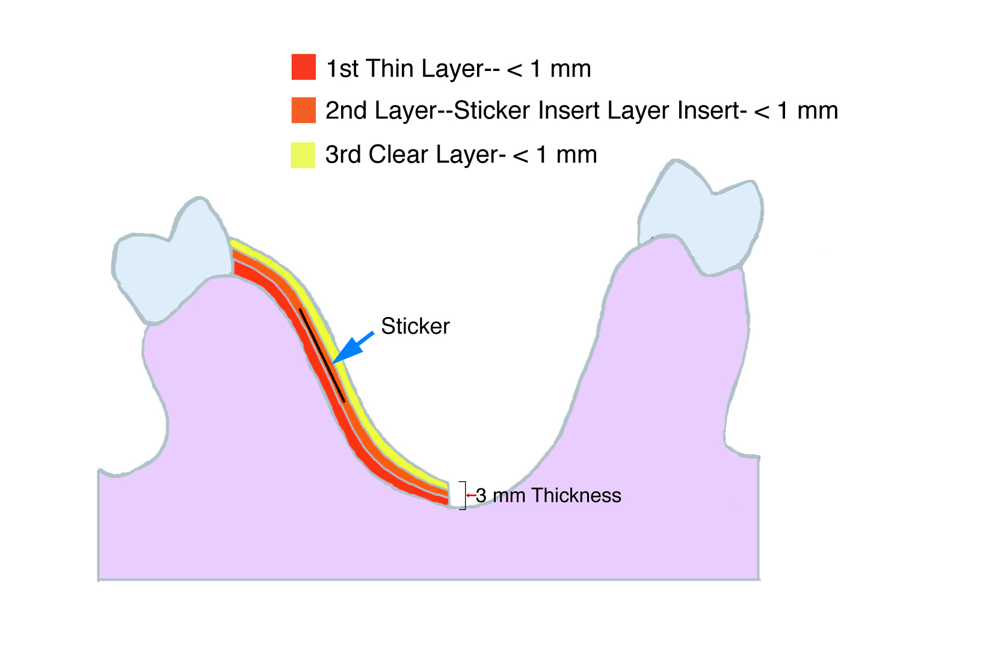

You will be able to insert stickers or decals into the retainers—
- As usual you will stack a very thin layer of acrylic down onto the palate. You will cover the retainer area with this thin 1st layer.

- Select the chosen sticker or decal and lay it down on the wet acrylic. Gently press the sticker onto the acrylic to eliminate any air that may be entrapped underneath the sticker.

- Using clear powder and clear liquid, cover the sticker.

- Revert to your regular pouring routine, and complete the pouring process for this appliance as you normally would, doing each section at a time, and to the normal desired thickness, completing the 2nd, 3rd or 4th portions of thickness of the appliance palate.

As you advance with more and different designs, experiment with more layers, keeping them very thin, with “color” only, not thickness. Use your initial layer(s) of application for color only, and the clear coat as your “thickness”-achieving layer.

After reading and trying to understand this, come back a few days later and re read. More of
this information will make more sense and your perspective will be different to the over all
process of applying stickers and doing “designs”.

